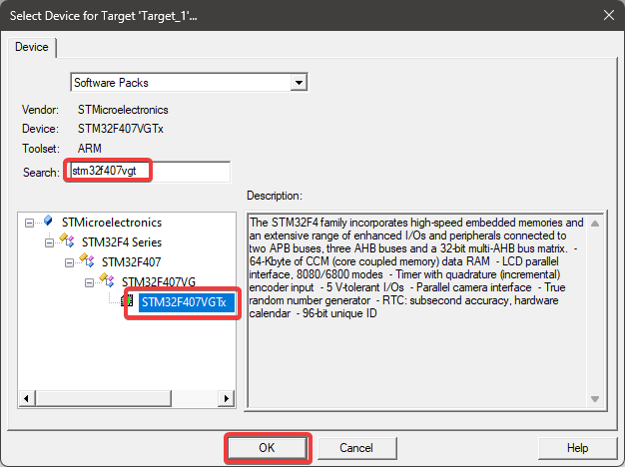

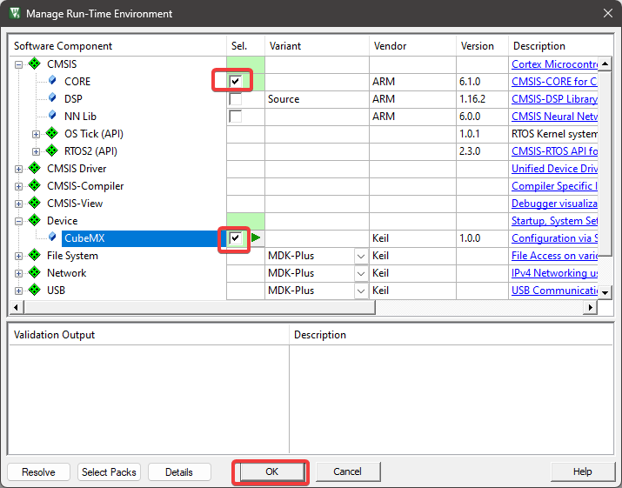

STM32Cumx Programı kapatılır

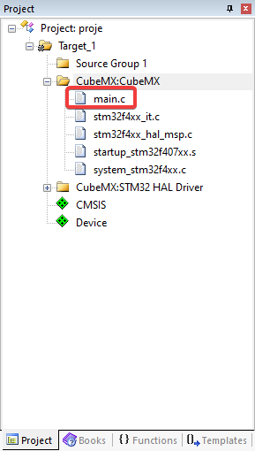

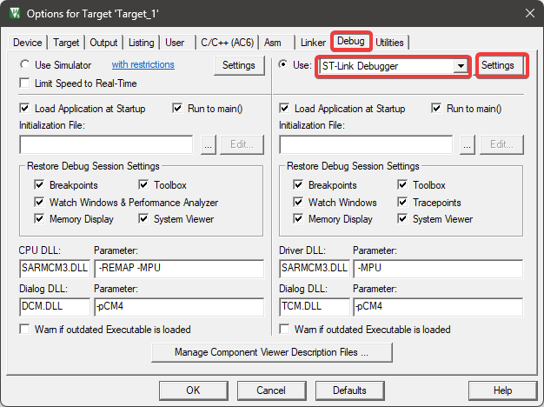

Options for Target penceresinde OK butonuna tıklanır.

Main.c dosyasındaki Cubemx tarafından oluşturulan kodlar silinir ve aşağıdaki gibi yeni kodlar yazılır.

